Practice Safe Sun

How to Practice Safe Sun
The American Academy of Dermatology (AAD) encourages you to #PracticeSafeSun whenever you're outdoors. When you Practice Safe Sun, you protect your skin from the sun's harmful rays. Here's why it's important:
- The sun's harmful rays can cause skin cancer.
- Everyone is at risk of getting skin cancer; about 1 in 5 Americans will develop skin cancer during their lifetime.
- Skin cancer is one of the most preventable cancers.
- When you protect your skin from the sun's harmful rays, you reduce your risk of developing skin cancer as well as premature skin aging.
To protect your skin from the sun's harmful rays, dermatologists recommend that you:
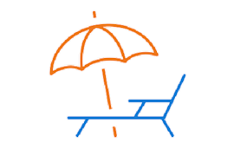
Seek shade
Seek shade when appropriate, remembering that the sun’s rays are the strongest between 10 a.m. and 2 p.m. You can also look at your shadow. Any time your shadow is shorter than you, seek shade.
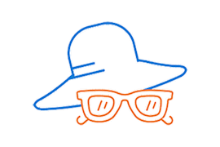
Wear sun-protective clothing
Wear a lightweight and long-sleeved shirt, pants, a wide-brimmed hat, and sunglasses with UV protection, when possible. For more effective protection, select clothing with an ultraviolet protection factor (UPF) number on the label.
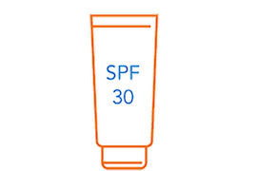
Apply sunscreen
To all skin not covered by clothing, apply a sunscreen that offers:
- Broad-spectrum protection
- Water resistance
- SPF of 30 or higher
When this sunscreen is also a tinted sunscreen with iron oxide, you better protect your skin from dark spots. Iron oxide protects your skin from the sun’s visible light. Tinted sunscreens do not leave the white residue or “cast” on your skin that some sunscreens do. Choose a tinted sunscreen that matches your skin tone.
Remember to reapply your sunscreen every 2 hours or after swimming or sweating.
Related AAD resources
- How to perform a skin self-exam
- What to wear to protect your skin from the sun
- Sunscreen FAQs

Last updated: 4/11/24

